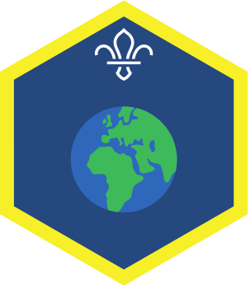
POLAND EVENING FOR THE
OUR WORLD CHALLENGE AWARD

Your name:

- Describe in the box below a game that Cubs in Poland play. Is it similar to a game which is played by Cubs in the UK?

- Write in the box below the Promise which is said by Cub Scouts in Poland.
- Write in the box below the name of a festival in Poland and describe what happens during it.

